Practical 1

Caesar Cipher

Problem:

The task is to implement a Caesar Cipher, a simple encryption technique where each letter in the plaintext is shifted a certain number of places down the alphabet. This practical involves creating a program that can both encrypt and decrypt messages using this cipher.

Description:

The Caesar Cipher is a substitution cipher where each letter in the plaintext is shifted by a fixed number of positions in the alphabet. This implementation also shifts digits and preserves non-alphabetic characters. For example, with a shift of 3, "abc123" becomes "def456". If "def456" is decrypted with a shift of 3, it returns to "abc123". The program continues to prompt users to encrypt or decrypt messages until they choose to exit, applying shifts dynamically based on the message length.

Code:

1. Ceasar-Cipher.py

from art import logo

# print the logo from the art.py file
print(logo)

# Encrypting code function
def encrypt(text, shift):
cipher_text = ""
# initialising an empty string

for char in text:
if char.islower(): # for lower case
shifted_char = chr((ord(char) - ord('a') + shift) % 26 + ord('a'))
cipher_text += shifted_char
elif char.isupper(): # for upper case
shifted_char = chr((ord(char) - ord('A') + shift) % 26 + ord('A'))
cipher_text += shifted_char
elif char.isdigit(): # for digits
shifted_char = chr((ord(char) - ord('0') + shift) % 10 + ord('0'))
cipher_text += shifted_char
else:
cipher_text += char # non-alphabetic characters remain unchanged
return cipher_text

# Decrypting code function
def decrypt(text, shift):
return encrypt(text, -shift) # Decrypting is just encrypting with negative shift

# Main block of code
while True:
choice = input("Type 'e' to encrypt and 'd' to decrypt or any other key to exit: ")

if choice.lower() == "e" or choice.lower() == "d":
text = input("Type your message: ")
user_shift = int(input("Type the shift number: "))
shift = user_shift * len(text)
if choice.lower() == "e":
result = encrypt(text, shift)
print(f"The encoded text is: {result}")
else:
result = decrypt(text, shift)
print(f"The decoded text is: {result}")
else:
break

Output:
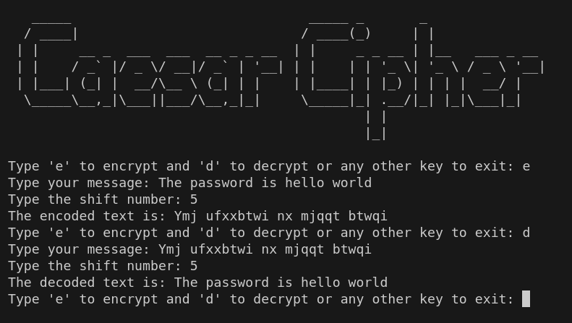

Code Explanation:

1. Import and Print Logo: The code starts by importing and printing a logo from the `art.py` file.

2. Encrypt Function:
- Iterates through each character in the input text.
- Shifts lowercase and uppercase letters within their respective ranges.
- Shifts digits within their range.
- Leaves non-alphabetic characters unchanged.

3. Decrypt Function:
- Utilizes the `encrypt` function with a negative shift to reverse the encryption.

4. Main Block:
- Continuously prompts the user for input to either encrypt or decrypt a message.
- Computes the shift based on user input and the length of the text.
- Displays the encrypted or decrypted result based on user choice.

Performance Analysis:

- Space Complexity:
- The space complexity of this program is O(n), where n is the length of the input text. This is because the program needs to store the `cipher_text` which is of the same length as the input text.

- Time Complexity:
- The time complexity is O(n), where n is the length of the input text. This is because the program iterates through each character of the text once to perform the encryption or decryption operation.

